**Day 3 – E-Mail Service**

1. Research the following internet protocols related to e-mail services.
   1. SMTP Protocol
      1. Allows your PC to send mail
      2. Simple Mail Transfer Protocol
      3. It’s the protocol used when you hit “Send” to transfer your email message
      4. It’s also the protocol used behind the scenes to transfer your message from server to server as it makes its way to the server on which your recipient receives email
      5. It's also used for relaying or forwarding mail messages from one mail server to another
      6. The ability to relay messages from one server to another is necessary if the sender and recipient have different email service providers
   2. POP3 Protocol
      1. Allows your PC to read mail
      2. The language computers use to talk between themselves
      3. POP — the post office protocol — is the language used between a computer fetching email and the computer holding your email
      4. Thunderbird and Microsoft Office’s Outlook desktop program are two examples the “3”in POP3 indicates that we’re all using version three of the POP protocol
      5. Designed around the assumption that when you access your email, you want to download it to the computer you’re using
      6. So after your email program fetches email via POP3, that email resides only on your computer and nowhere else
      7. It’s best when you only read your email from a single location: your PC.
   3. IMAP Protocol
      1. IMAP is another protocol used by email programs to access your email.
      2. IMAP is an alternative to POP3, and works in a fundamentally different way. Those differences make it a frequently-preferred alternative in today’s always-connected world.
      3. IMAP assumes you want to leave the master copy of your email on the email server
      4. IMAP is simply a way of looking at that master copy from a connected device
      5. IMAP was designed with the goal of permitting complete management of an email box by multiple email clients
   4. Web Mail
      1. All mail stays on the server
      2. Server provides a dynamic web site that you access  
         through a web browser
      3. Web-based email, such as Outlook.com, Yahoo, and the like, displays the email directly from their servers to your web browser
      4. Uses SMTP behind the scenes to get and send email
      5. There’s no configuration needed other than logging in
2. Use the following resource as a starting point:  
   <https://askleo.com/what_is_pop_or_pop3_or_a_pop_account_and_what_about_smtp/>
3. Complete the following Venn Diagram to summarize your research. 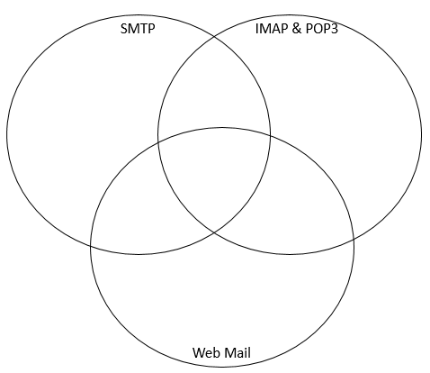

Web Mail may use IMAP or POP3 behind the scenes to get and send email

Web Mail uses SMTP behind the scenes to get and send email

They are used by users

They all use login

e.g. Microsoft Outlook, Thunderbird or Apple Mail

SMTP, which is specified in RFC 5321, uses port 25 by default.

Allows your PC to send mail

SMTP is used by the client to send emails to a server but it is also used by servers to push the email to another server

Simple Mail Transfer Protocol

Configuring a SMTP server generally requires the same thing for POP3/IAMP

Relays messages from one server to another

There’s no configuration needed other than logging in

Web Mail offers complete access to your mail without any mail being downloaded to your computer

Web-based email, such as Outlook.com, Yahoo, and the like, displays the email directly from their servers to your web browser

Another protocol used by email programs to access your email

Assumes you want to leave the master copy of your email on the email server

Designed around the assumption that when you access your email, you want to download it to the computer you’re using

Server provides a dynamic web site that you access

through a web browser

The language computers use to talk between themselves

They are all used in the e-mail process